Output for Even-Odd Tabulation Techniques

1. Using Boolean Array

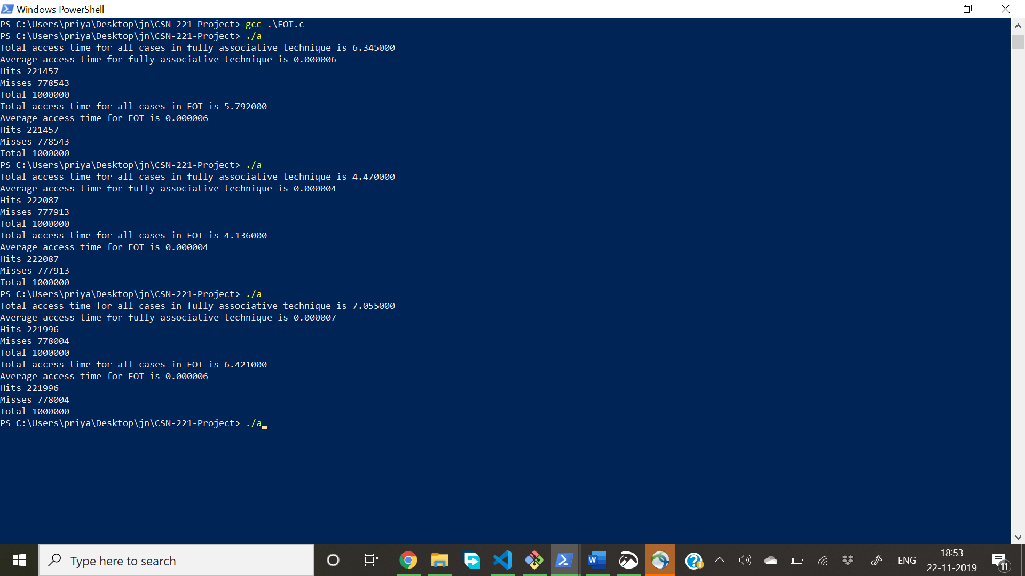

In last case –

Time for fully associative cache – 7.055

Time using EOT – 6.421

2.Using Stack Approach

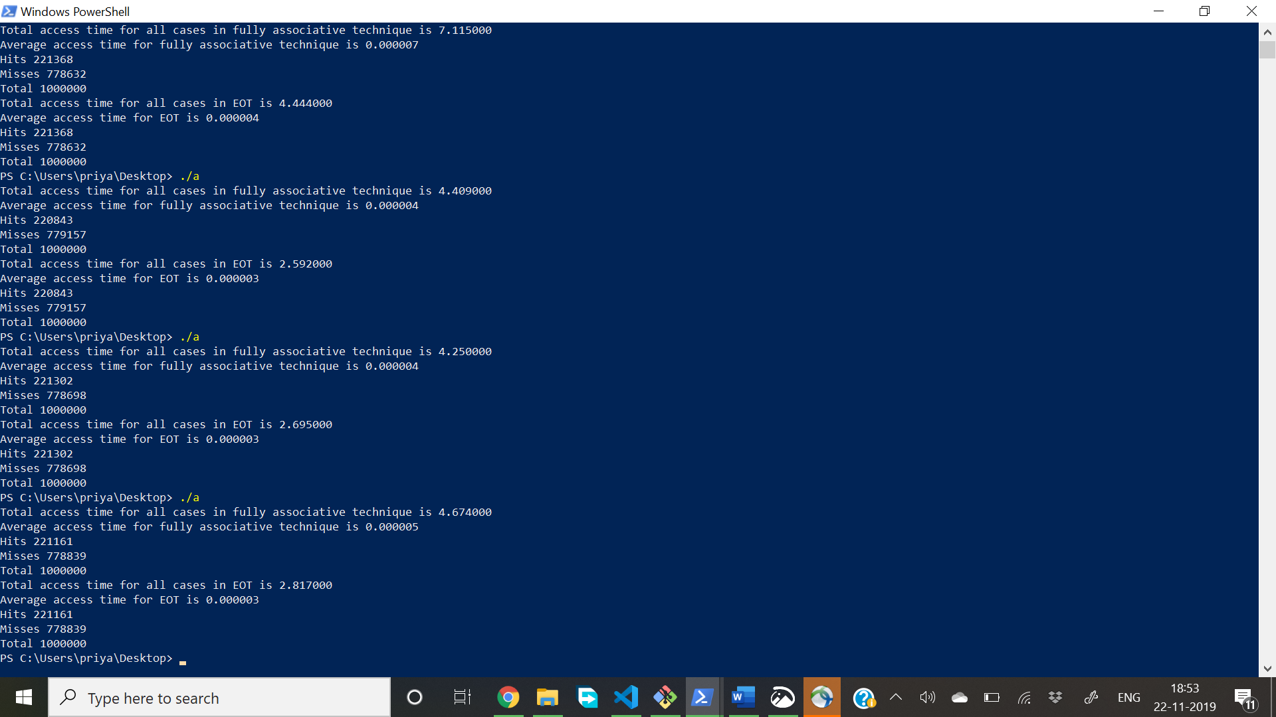

In last case-

Time in fully associative cache- 4.674

Time using EOT and stack approach-2.817